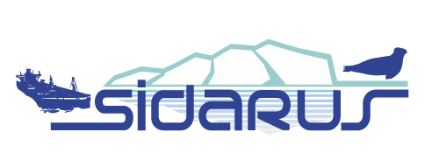 | Sea Ice Downstream Services for Arctic and Antarctic Users and Stakeholders  Collaborative project under FP7-SPACE 2011-2013

Sea ice information for marine safety
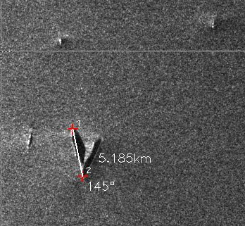 | 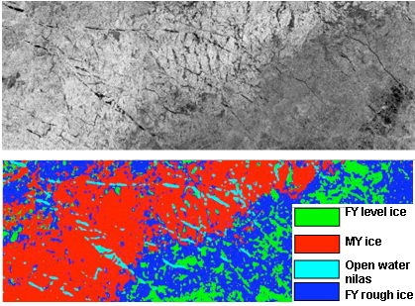
Iceberg detection using SAR images in the Antarctica (CLS) | Sea ice classification from SAR, showing multiyear, firstyear level, firstyear rough, and open water/nilas (NIERSC) | Ice forecasts of the ice edge location, sea ice concentrations ice velocity and ice thickness using the 4 km HYCOM model (NERSC)

Sea ice information combined with animal tracking
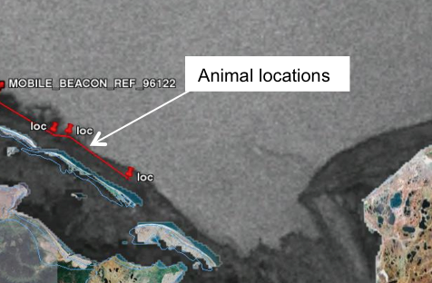 | 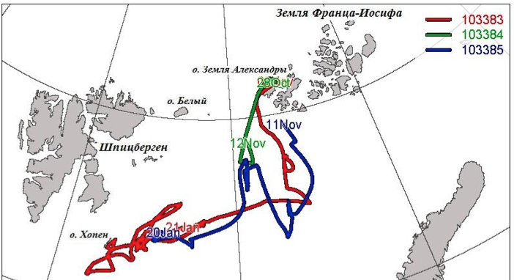
Tracking of beluga whales with Argos system combined with sea ice data in Okhotsk Sea, 15 November 2009 (CLS) | Trajectories of three polar bears with Argos tags in the Barents Sea in October – November 2010 (IPEE)

Sea ice thickness data for climate research
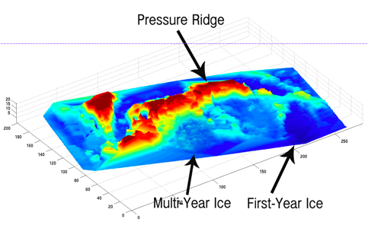 | 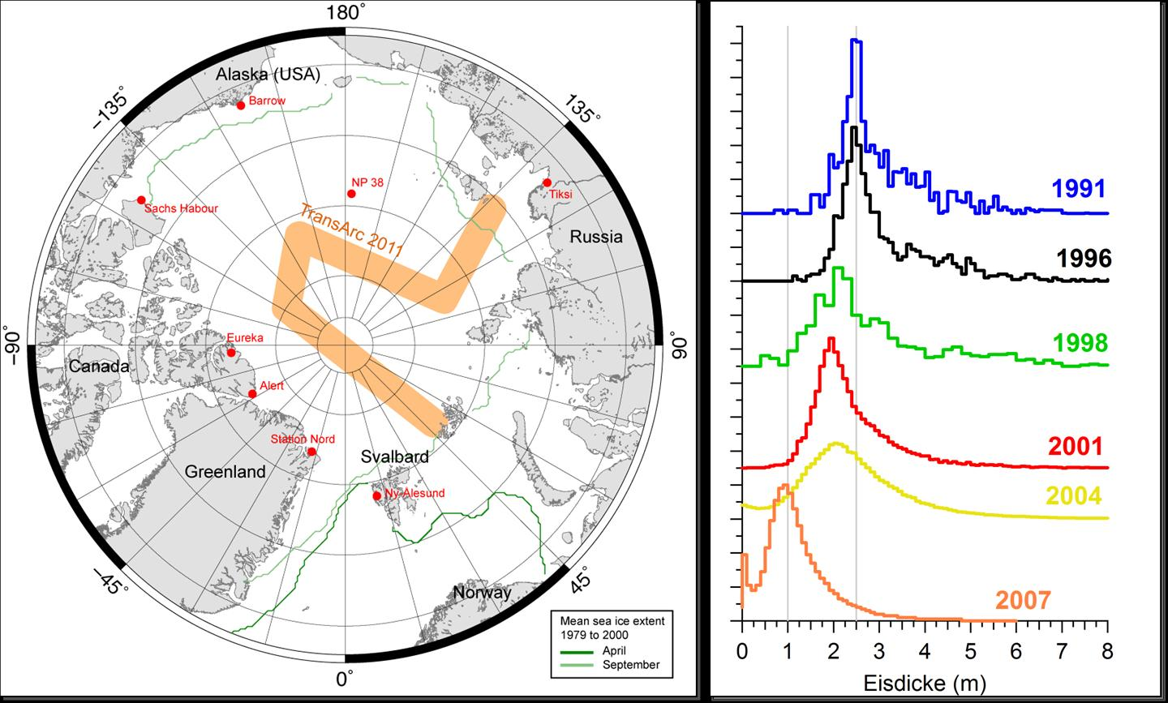 | 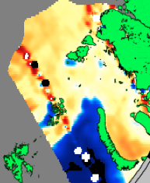
Sea ice thickness and ridges from multibeam sonar operated from Autonomous Underwater Vehicles ( UCAM) | Pan-Arctic measurements of  ice thickness (AWI) | SMOS h-polarisation brightness temperature (UB)

_________________________________________________________________________________________________________________

The overall objective of SIDARUS is to develop and implement a set of sea ice downstream services in the
area of climate research, marine safety and environmental monitoring. SIDARUS will extend the present GMES
services (Global Monitoring for Environmental and Security) with new satellite-derived sea ice products, ice forecasting from regional models, and validation of sea ice products using non-satellite data. The products are generated for different spatial scales which range from covering the entire Arctic and Antarctic regions to the local surrounding of offshore structures.

Benefits of Our Services

The demand from many user groups for improved sea ice information in the Arctic and Antarctic is growing as a result of climate change and its influence on the polar environment and on socio-economic conditions for marine operations. The presently observed reduction of the Arctic sea ice extent, in particular during the summer months, and an increasing demand for natural resources are key mechanisms driving human activities in these areas. In the Antarctic, ice discharge from several ice shelves which is regarded a significant indicator of climate change, needs to be monitored because the larger number of icebergs represents a serious thread on marine operations in the Southern Ocean. The SIDARUS project will address the needs of users and stakeholders in the area of marine safety, environmental monitoring and climate research.

Services

- High-resolution sea ice and iceberg mapping by SAR
  - Improvement of SAR-based sea ice classification methods to map details of the ice cover (leads, polynyas, ice types, deformed ice) as well as iceberg detection methods
- Sea ice albedo from optical sensors
  - Development of improved parameterization of sea ice albedo based on optical satellite data, required as input for sea ice and climate modelling
- Sea ice thickness from satellite radar altimeter and passive microwave data
  - Development and validation of ice thickness retrievals from satellite radar altimeter (CryoSat) and passive microwave data (SMOS), analysis of ice thickness data from field surveys for validation of satellite retrievals.
- ARGOS tracking of marine mammals combined with sea ice maps
  - Provision of integrated maps of marine mammal tracks from ARGOSS data together with sea ice maps from satellite data
- Ice forecasting based on numerical models and satellite data.
  - Improvement of regional sea ice forecasts for the Barents Sea area from downscaling of MyOcean services; provisions of iceberg forecasts in Antarctic waters by combining SAR detection and numerical ocean forecasting from MyOcean.
- Provide access to relevant sea ice products from other GMES services.

Consortium

- STIFTELSEN NANSEN SENTER FOR FJERNMAALING (NERSC) Norway
- ALFRED-WEGENER-INSTITUT FUER POLAR- UND MEERESFORSCHUNG (AWI) Germany
- COLLECTE LOCALISATION SATELLITES SA (CLS) France
- UNIVERSITAET BREMEN (UB) Germany
- THE CHANCELLOR, MASTERS AND SCHOLARS OF THE UNIVERSITY OF CAMBRIDGE (UCAM) United Kingdom
- METEOROLOGISK INSTITUTT (met.no) Norway
- Scientific foundation Nansen International Environmental and Remote Sensing Centre (NIERSC) Russian Federation
- B.I. Stepanov Institute of Physics of the National Academy of Sciences of Belarus Institute of Physics NAS of Belarus

Further Information:
Project coordinator:  stein.sandven@nersc.no (NERSC) | Coordinator for user interaction:  Frode.dinessen@met.no (met.no)  aduplaa@cls.fr (CLS) | SIDARUS website:  http://sidarus.nersc.no/  (under construction)

